YAYASAN MASJID PANGLIMA BESAR SOEDIRMAN
Sekolah Menengah Atas Islam (SMA Islam) PB Soedirman
Cijantung – Jakarta Timur
Status Akreditasi : Disamakan

Jl. Raya Bogor Km. 24 Cijantung, Jakarta 13770, Telp. 8400387. Ext. 124
e- mail : ympbs66@hotmail.com , website : members tripod.com/yasma 66/index.htm

TRY OUT UJIAN NASIONAL A
LEMBAR SOAL

Mata Pelajaran : BAHASA INGGRIS
Kelas/Program Studi : XII / IPA & IPS
Hari/Tanggal :
Jam :
__________________________________________________________________________________
Listening Section

In this section of the test, you will have the chance to show how well you understand spoken English. There are four parts to this section, with special directions for each part.

Part I
Questions 1 to 3.

Directions:
In this part of the test, you will hear some dialogues and questions spoken in English. The dialogues and the questions will be spoken twice. They will not be printed in your test book, so you must listen carefully to understand what the speakers are saying.

After you listen to the dialogue and the question about it, read the five possible answers and decide which one would be the best answer to the question you have heard. Now listen to a sample question.

You will hear:

Boy : Have you finished doing your homework?
Girl : Not yet.
Boy : Do it right away. The class will begin soon.

You will also hear:
Narrator: Where does the conversation take place?

Sample answer

You will read in your test book:
- At school
- At home.
- At a store
- At the mall
- At the market

The best answer to the question ‘Where does the conversation take place? is choice (A), ‘At school’.
Therefore, you should answer choice (A)

1. A. Food
B. Golf
C. Books
D. Free time
E. Spare time

2. A. In a bus
B. In a park
C. In an office
D. In an airplane
E. In a restaurant

3. A. The office is closed.
B. The post office isn’t close.
C. The post office is near here.
D. The post office is around here.
E. The post office is on the bus route.

Part II
Questions: 4 to 8

In this part of the test, you will hear some incomplete dialogues spoken in English, followed by five responses, also spoken in English. The dialogues and the responses will be spoken twice. They will not be printed in your test book, so you must listen carefully to understand what the speakers are saying. You have to choose the best response to each question or statement.

Now listen to a sample question:

You will hear:
Woman: Good morning, John. How are you? Sample answer
Man : ….

You will also hear:

- I am fine, thank you.
- I am in the living room.
- Let me introduce myself.
- My name is Hendra Gunawan.
- I have been here since this morning.

The best answer to the question ‘How are you?’ is choice (A), ‘I’m fine, thank you.’
Therefore, you should choose option (A)

4. Mark your answer on your answer sheet.
5. Mark your answer on your answer sheet.
6. Mark your answer on your answer sheet.
7. Mark your answer on your answer sheet.
8. Mark your answer on your answer sheet.

Part III
Questions 9 to 11.

Directions:
In this part of the test, you will hear some dialogues or monologues spoken in English. The dialogues or monologues will be spoken twice. They will not be printed in your test book, so you must listen carefully to understand what the speakers are saying. After you listen the dialogue or monologue, look at five pictures provided in your test book, and decide which one would be the most suitable with the dialogue or monologue you have heard.

9.
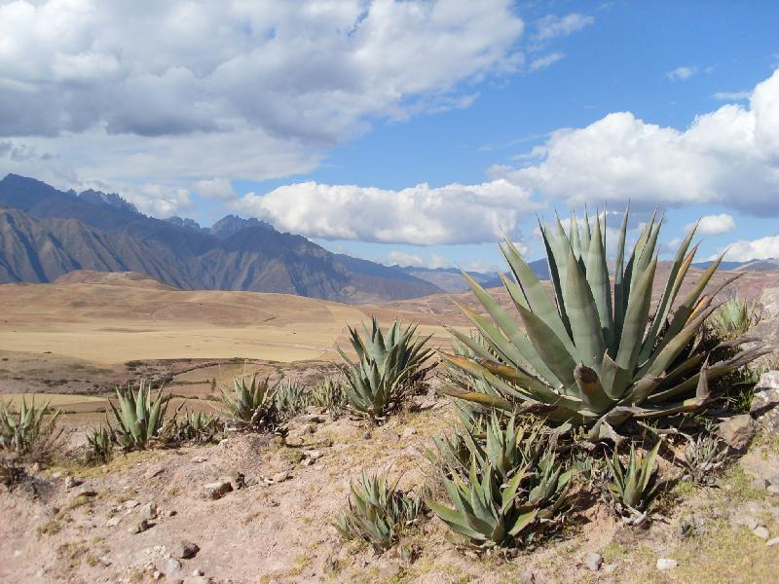
1 2 3


4 5
A. 1
B. 2
C. 3
D. 4
E. 5

10.
- 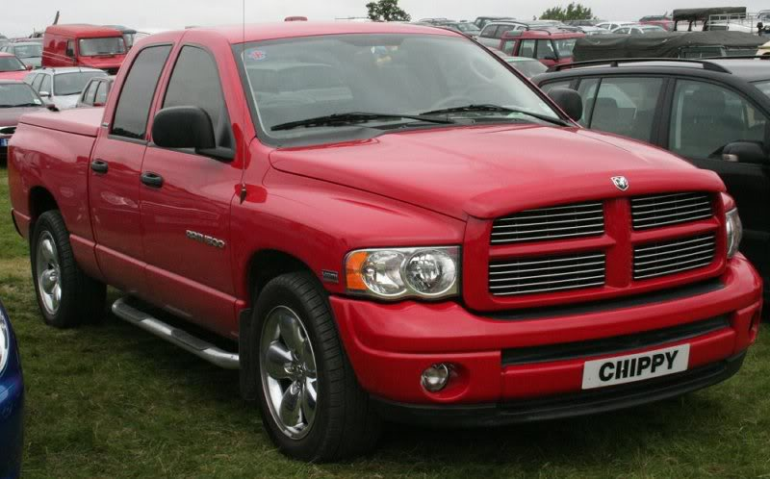
- 2

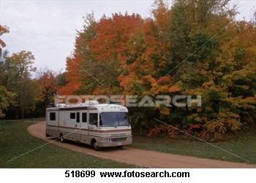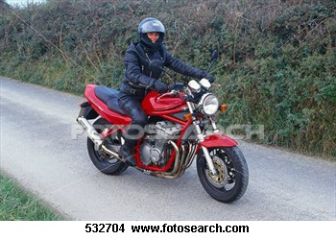
3 4


5

- 1
- 2
- 3
- 4
- 5

11.

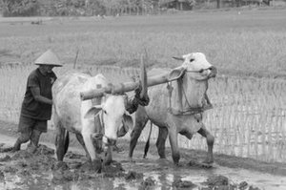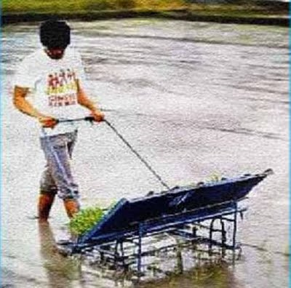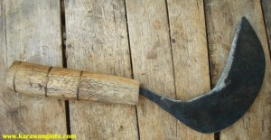
1 2 3

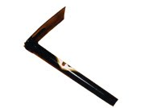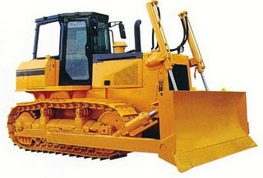
4 5

- 1
- 2
- 3
- 4
- 5

Part IV
Questions: 12 to 15

Directions:
In this part of the test, you will hear several monologues. Each monologue will be spoken twice. They will not be printed in your test book, so you must listen carefully to understand what the speakers are saying.

After you hear a monologue and the question about it, read the five possible answers and decide which one would be the best answer to the question you have heard.

12. A. small village.
B. Grandmother’s house.
C. Buildings in Greenfield.
D. A visit to grandmother’s village.
E. Greenfield, a quiet and peaceful village.
13. A. The fox.
B. The hare.
C. The witch.
D. The fox’ wife.
E. The hare’s wife.
14. A. A wonderful parrot.
B. An annoying parrot.
C. A surprised parrot.
D. A strange parrot.
E. A funny parrot.

15. A. It learns ”saying Catano” for while before it.
B. It’s ashamed to say the word “Catano”.
C. It is lazy to say the word “Catano.”
D. It is hard to say the word “Catano.”
E. It doesn’t like to say “Catano”.

This is the end of the listening section.

Reading Section
The following text is for questions 16 - 18.

To : Don
From : Rita
Don,
Sorry I cannot wait for you any longer. I am away either for lunch or in a meeting now.
I put the file you need in the filing cabinet. It is in a red document file. I put the key in the drawer of my desk. If you cannot find ask the file clerk for help.
The office supplies you ordered are in the cupboard. Please, leave two boxes of paperclips and a punch and some portfolio.
Don’t forget the meeting is in the conference room and starts at 10 am tomorrow.

16. The text is about ….
A. A file and office supplies ordered
B. A file clerk
C. A red document file
D. The conference room
E. A meeting

17. ‘It is in a red document file.’ (Line 3)
The underlined word refers to ….
- the key
- a punch
- file
- filing cabinet
- red document

18. “The office supplies you ordered are in the cupboard.”
A. sent for
- charged for
- reserved for
- arranged for
- asked for

The following text is for questions 19 - 20.

Tonight’s dinner honors our colleague Ms. Radice. Ms. Radice will receive the Good Citizen Award for saving the life of our coworker Mr. Chi. Two months ago
Ms. Radice went beyond the call of duty of her job by taking a first-aid course. She did this after learning that very few of our employees knew how to administer CPR. A survey of our staff showed that only 1 in 10 of our employees had first – aid certificate. Ms. Radice took the course on her own time and at her own expense. Her initiative paid off by saving a life. To begin our program our director, Mr. Prince, will make a special announcement.

19. The text tells about ….
A. Mr. Prince’s announcement
B. a coworker, Mr. Chi
C. a first-aid certificate
D. the Good Citizen Award
E. an award dinner

20. The dinner party will begin with ….
A. saving a life
B. serving dinner
C. delivering a speech
D. giving the award
E. announcing the program

The following text is for questions 21 - 23

Jamie Roberts and Damien Duval

in

The Blue Sapphire

Plaza Drive-in Early Bird Matinee
Mayfield at Route 303 $2 till 5 P.M.

Starts tomorrow
Daily at 2 4 6 8 10

21. How many showings will there be each day?
A. 2
B. 4
C. 5
D. 6
E. 10

22. What is the title of the movie?
A. The Blue Sapphire.
B. Plaza Drive-in.
C. Jamie Roberts
D. Early Bird Matinee.
E. Mayfield at Route 303

23. “Plaza Drive-In” is a cinema where people stay in … while watching the film.
A. the park
B the parking lot
C. their seats
D. the building
E. their cars

The following text is for questions 24 - 27.

CHICAGO. People with breathing problems that disrupt their sleep were less tired after three weeks of treatment with a breathing device compared to those treated with a placebo, US researches said on Saturday.
The findings show that regular use of treatment with continuous positive airway pressure (CPAP) masks reduce fatigue caused by obstructive sleep apnea, a chronic disorder that affects 12 million Americans.
Sleep apnea raises the risk of high blood pressure, heart attack, stroke, irregular heartbeat and diabetes.
It occurs when soft tissue in the back of the throat collapses during sleep, blocking the airway and causing the brain to rouse the sleeper, who gasps for air – a cycle that can occur as many as 30 times in an hour.
CPAP disrupts this cycle by providing a steady stream of air through a mask that keeps the airway open during sleep
Companies that make CPAP treatments include Graymark Healthcare and ResMed Inc.
This results are important as they highlight that patients who comply with CPAP therapy can find relief from fatigue and experience increases in energy and vigor after a relatively short treatment period,” Lianne Tomfohr of San Diego State University and the University of California, San Diego, whose study appears in the journal Sleep, said in a statement-Reuters.

24. The text is about ….
A. breathing problems
B. treatment with CPAP
C. CPAP, a breathing device
D. obstructive sleep apnea
E. Lianne Tomfohr’s study

25. CPAP masks reduce ….
A. stroke
B. fatigue
C. diabetes
D. heart attack
E. high blood pressure

26. A sleeper will suddenly rise from his/her sleep because ….
A. the energy increases
B. the airway is blocked
C. the blood pressure rises
D. the heart beats irregularly
E. there is a chronic disorder

27. “Peopled with breathing problems that disrupts their sleep ….” (Paragraph 1)
The underlined word is rather similar in meaning to ….
- alters
- spoils
- disturbs
- worsens
- damages

The following text is for questions 28 - 31.

During the summer, we went to the beach every day. We stayed at a lovely motel right on the beach. In the morning we would get up at 9.30, have breakfast, and then spend four hours near the pool with all the other guests. At 1.00 we would have lunch in our room. For lunch we would eat something light like sandwiches and fruit. In the afternoon we would return to the pool area and sit in the sun for a while. At night we would take long walks along the beach or visit some friends who lived at 520 Volusia Avenue in Daytona Beach.
Many people from out of town stayed at the motel. Like us, they had been coming to that same motel since 2005. Most of them were from Ohio. From time to time we would eat out at a nice restaurant, where we did not have to wait long for the waitress to serve us. In July it is usually very crowded, but this year at least, it was not as crowded as in the past. Once in a while, we went to the movies at the theater on the corner of Las Olas Boulevard and Castillo Avenue. We arrived there in no time in all by car.

28. What did the writer do in the afternoon?
A. Sit in the sun.
B. Take long walks
C. Go to the movies.
D. Visit some friends.
E. Eat at a nice restaurant.

29. The main idea of the second paragraph is ….
A. The theater is near the motel.
B. The restaurant is always crowded.
C. The writer and the people from Ohio had been coming to the motel since 2005.
D. The location of the theater is on the corner of Las Olas and Castillo Avenue.
E . The writer sometimes went to the movies.

30. Which statement is TRUE?
A. The menu of break fast is sandwiches and fruit.
B. The theater is always crowded.
C. The restaurant offers special menu.
D. The visitors were not interested in the motel.
E. The motel is small and cheap.
31. “Once in a while, we went to the movies ….” (Paragraph 2)
The underlined phrase means ….
- often
- always
- usually
- generally
- sometimes

The following text is for questions 32 - 36.

Parasitic plants depend entirely on their hosts for their nourishment. They have no green leaves and so cannot photosynthesize food. Instead they bore into the tissues of other plants and take the food they need.
Parasitic plants are those that live on other plants without giving any benefit to their hosts in any way. In some cases, parasites cause harm to their hosts. For example, parasitic fungi cause wheat and beans rust, potato and tomato blight, apple scab, and downing mildew of grapes.
Dodders are one of the largest groups of parasitic plants. They have long, twining red or yellow stems, with tiny scale like leaves. Most dodders live off small plants, such as nettles or gorse, but some are parasites of trees. A young dodder seedling quickly twines round a host plant, and buries its suckers (haustoria) into it in many places as it can.
Broomrapes and toothworts are also common parasites. Broomrapes attack such plants as clover and daisies, while toothworts are parasites of trees, such as hazel. Both of these parasites attack the roots of their hosts.
One of the most extra-ordinary parasites in Rafflesia. Its huge flower, the largest in the world, is the only visible part of the plant. The remainder consists of threads buried in the host’s roots.

32. What is the effect of parasitic fungi on wheat?
It becomes ….
- blight
- rusty
- scabby
- reddish
- yellowish

33. The text tells how parasitic plants ….
A. harm their hosts
B. get their food
C. attack their hosts
D. photosynthesize food
E. twin round a host plant

34. Which parasitic plant sucks its host in many places?
A. Fungi.
B. Rafflesia.
C. Broomrapes.
D. Toothworts
E. Young dodders.

35. The communicative purpose of the text is to tell the readers ….
A. parasitic plants
B. what parasitic plants are
C. parts of the host plant attacked by parasitic plants
D. what plants are affected by parasitic plants
E. how parasitic plants get their food

36. “In some cases, parasites cause harm to their hosts.” (Paragraph 1)
The underlined word means …..
- damage
- loss
- pain
- injury
- disadvantage

The following text is for questions 37 - 41.

Nuclear power is generated by uranium which is a metal mined in various part of the world. The first large-scale nuclear power station was opened at Calder Hall Cumbria, England, in 1956.
Some military ships and submarines have nuclear power plant for engines. Nuclear power produces around 11% of the world’s energy needed, and produces huge amounts energy. It causes no pollution as you’d get when burning fossil fuels.
The advantages of nuclear as follows:
- It costs about the same as coal, so it is not expensive to make
- It doesn’t produce smoke or carbon dioxide, so it doesn’t contribute to the greenhouse effect.
- It produces huge amounts of energy from small amount of uranium.
- It produces small amounts of waste.
- It is reliable.
On the other hand, nuclear power is very, very dangerous. It must be sealed up and buried for many years to allow the radioactivity to die away. Furthermore, although it is reliable, a lot of money has to be spent on safety because if it does go wrong, a nuclear accident can be a major disaster.
People are increasingly concerned about this. In the 1990’s nuclear power was the fastest growing source of power in many parts of the world. In 2005, it was the second slowest growing.

37. The first large-scale nuclear power station was opened in England in ….
A. 1950
B. 1996
C. 1990
D. 1956
E. 2005

38. The text tells about ….
A. the disadvantages and disadvantages of nuclear power
B. nuclear biggest station
C. the danger of radioactive
D. the disadvantages of nuclear power
E. nuclear in general

39. The main idea of the fourth paragraph is ….
A. Nuclear power is dangerous
B. Nuclear power is safe
C. Nuclear is reliable
D. A nuclear accident can be a major disaster
E. It needs many years to die the radioactivity

40. Which statement do you agree with about nuclear?
A. It is costly to make.
B. It is reliable
C. It causes air pollution.
D. It affects the greenhouse.
E. It produces small amounts of energy.

41. ‘The advantages of nuclear as follows.’
The underlined word means ….
- aids
- profits
- superiority
- convenience
- benefits

The following text is for questions 42 - 46.

Peter J.D’ Adamo is a naturopath who treats illness by such means as changing the food that people eat, and tries to help the body to cure itself without the use of dangerous drugs. In this book “Eat Right 4 Your Type”, he writes that our blood type determines what food should be included or avoid in our diet and what food is neutral. He also writes that type O blood is the original blood type.
On the other hand, Mr. Soekirman, a professor in nutrition science at Bogor Agricultural University asserts that there is no consensus in the scientific community that O is the original blood type. He also says that there is no research published to back up D’ Adamo’s theories.
He, however, does agree that appropriate diet varies from individual to individual according to age, weight, condition of health, climate, and amount of activity.
He says that we can loose our weight if we only eat certain food but it is not a healthy diet.
I think eating organic food is much healthier although it doesn’t taste good.

42. In paragraph 3, Prof. Soekirman agrees that appropriate diet varies according to the following, Except….
A. Blood type
B. Weight
C. Climate
D. Age
E. Conditional of health

43. The text is about….
A. Organic food
B. Original blood type
- Appropriate diets
D. Nutrition science
E. Curing the body by itself

44. Which of the following is totally refused by Mr. Soekirman?
A. Blood types determine the kinds of food to eat
- Organic food is healthy but expensive
C. Eating only certain food is not recommended
D. O is the original type of blood
E. Appropriate diet varies from individual to individual

45. It is advisable to people who want to diet….
A. to go to a doctor or a dietician
B. to follow blood type diet
C. to eat organic food
D. to eat food high in protein and fruit
E. to avoid eating food containing fat and carbohydrate

- “On the other hand…asserts that….” (Paragraph 2)
The underlined word means….
A. agrees
B. denies
C maintains
D. affirms
E. states

The following text is for questions 47 - 50.

Now Showing
Bad Santa (Drama/Crime, 91 minutes) Starring Billy Bob Thornton, Tony Cox, Brett Kelly, Lauren Graham, John Ritter, Bernie Mac. Written by Glenn Ficarra & John Requa. Directed by Terry Zwigoff.
After all the fluffy warm holiday films, this offensive, irrevently funny movie is probably just what we need.
A jerk (Thornton) who’s always drunk works as Santa in malls with his midget partner (Cox) posing as his Little Helper.
On Christmas Eve, they plan to rob the mall and spend the money until next Christmas.
But this year, their plan to crash another mall is interrupted when Santa befriends a troubled kid who believe that the drunk, foul-mouthed loser is really Santa.
Often shocking, uncompromising ode to cynicism, with Thornton giving his best performance in years.
A must see, but for adults only.

47. The film is directed by ….
A. Tony Cox
B. John Requa
C. Brett Kelly
D. Lauren Graham
E. Terry Zwigoff

48. The film is about ….
A. a midget partner
B. a fake Santa
C. a drunken Santa
D. Santa’s Little Helper
E. an ungraceful Santa

49. The film is for adults only because ….
A. it is a funny movie
B. it is made on location
C. it does not portray the true good characters of a Santa
D. the leading role is not a real Santa
E. the film is too long for a kid

50. “After all the fluffy, warm holiday films, this offensive ….” (Paragraph 2)
The underlined word means ….
- proper
- pleasant
- educated
- eccentric
- impolite

GOOD LUCK, GUYS !

